## 1. Create the React App

npx create-react-app cricketappcd cricketapp

2. Folder and Component Setup

Create two files inside src/:

ListofPlayers.js

IndianPlayers.js

Also modify App.js to include a flag for conditional rendering.

3. ListofPlayers.js — Use map() & arrow functions

// src/ListofPlayers.jsimport React from "react";

const ListofPlayers = () => {

const players = [

{ name: "Virat", score: 95 },

{ name: "Rohit", score: 88 },

{ name: "Hardik", score: 72 },

{ name: "Rishabh", score: 69 },

{ name: "Shreyas", score: 55 },

{ name: "Rahul", score: 77 },

{ name: "Shami", score: 42 },

{ name: "Bumrah", score: 65 },

{ name: "Jadeja", score: 91 },

{ name: "Ashwin", score: 73 },

{ name: "Gill", score: 81 },

];

// Players with score < 70 (using arrow function)

const filteredPlayers = players.filter((player) => player.score < 70);

return (

<div>

<h2>🏏 All Players</h2>

{players.map((player, index) => (

<p key={index}>

{player.name} - Score: {player.score}

</p>

))}

<h2>📉 Players with Score Below 70</h2>

{filteredPlayers.map((player, index) => (

<p key={index}>

{player.name} - Score: {player.score}

</p>

))}

</div>

);

};

export default ListofPlayers;

4. IndianPlayers.js — Use destructuring, spread, array merge

// src/IndianPlayers.jsimport React from "react";

const IndianPlayers = () => {

const team = ["Virat", "Rohit", "Gill", "Rahul", "Rishabh", "Hardik"];

// Destructuring to get odd and even team members

const oddTeam = team.filter((_, index) => index % 2 !== 0);

const evenTeam = team.filter((_, index) => index % 2 === 0);

// Merge arrays using spread operator

const T20players = ["Bumrah", "Jadeja"];

const RanjiPlayers = ["Shreyas", "Ashwin"];

const mergedPlayers = [...T20players, ...RanjiPlayers];

return (

<div>

<h2>🔁 Team Splits (Destructuring)</h2>

<p>Odd Team Players: {oddTeam.join(", ")}</p>

<p>Even Team Players: {evenTeam.join(", ")}</p>

<h2>🔗 Merged Players (T20 + Ranji)</h2>

<p>{mergedPlayers.join(", ")}</p>

</div>

);

};

export default IndianPlayers;

5. Conditional Rendering in App.js

// src/App.jsimport React from "react";import ListofPlayers from "./ListofPlayers";import IndianPlayers from "./IndianPlayers";

function App() {

const flag = true; // change to false to show IndianPlayers

return (

<div style={{ textAlign: "center", marginTop: "30px" }}>

<h1>🏏 Welcome to Cricket App</h1>

{flag ? <ListofPlayers /> : <IndianPlayers />}

</div>

);

}

export default App;

**OUTPUT:**

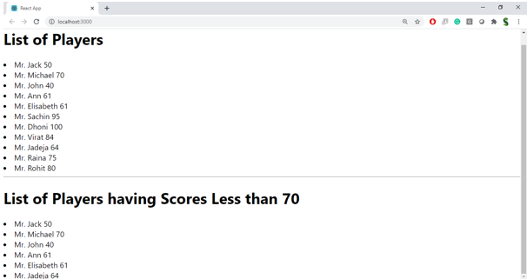

When Flag=false

